## SQL HANDS ON

### SQL Basics with DML and DDL Statements

SCHEMA

## CAR

## Car rental system - Create Table

Refer to the given schema. Write a query to create the Owners table with the specified columns and constraints.

Note: Letters in bold represents the table name

NOTE: Maintain the same sequence of column order, as specified in the question description

**create table OWNERS(owner_id varchar(20) primary key,**

**owner_name varchar(20),**

**address varchar(20),**

**phone_no bigint,**

**email_id varchar(20));**

## Car rental system - add new column

Refer to the given schema. Assume, CARS table has been already created. Write an appropriate query for the given requirement.

Requirement 1: Add a new column Car_Regno VARCHAR(10)  to the Cars table.  
  
Note: Letters in the bold represents the attribute name.

**alter table CARS ADD COLUMN car_regno varchar(10);**

## Car rental system - Insert values

Refer to the given schema diagram. Insert the below records into Rentals Table. Assume the rentals table has been already created.

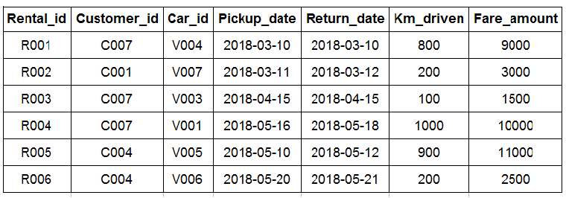

Note: Letters in bold represent the attributes.

NOTE: Maintain the same sequence of column order, as specified in the question description

**insert into rentals values('R001','C007','V004','2018-03-10','2018-03-10',800,9000); insert into rentals values('R002','C001','V007','2018-03-11','2018-03-12',200,3000); insert into rentals values('R003','C007','V003','2018-04-15','2018-04-15',100,1500); insert into rentals values('R004','C007','V001','2018-05-16','2018-05-18',1000,10000); insert into rentals values('R005','C004','V005','2018-05-10','2018-05-12',900,11000); insert into rentals values('R006','C004','V006','2018-05-20','2018-05-21',200,2500);****select * from rentals order by 1;**

## Car & owner details based on car type

Write a query to display car id, car name and owner id of all the cars whose car type is 'Hatchback' or 'SUV'.  Sort the result based on car id.

(Hint: Use  CARS tables to retrieve records. Data is case-sensitive. E.g: Car_type='Hatchback'. Use IN operator)

NOTE: Maintain the same sequence of column order, as specified in the question description

**select car_id,car_name,owner_id**

**from cars where car_type='SUV' or car_type='Hatchback'**

**order by car_id;**

## Car details based on type and name

Write a query to display car id, car name and car type of Maruthi company 'Sedan' type cars.  Sort the result based on car id.

(HINT : Use Cars table to retrieve records.car name='Maruthi Swift'.car type='Sedan'.Data is case sensitive.)

NOTE: Maintain the same sequence of column order, as specified in the question description

**Select car_id,car_name,car_type from cars where car_name like 'Maruthi%' and car_type='Sedan' order by 1;**

## Customers having gmail id

Write a query to display customer id, customer name, address, and phone number of customers having Gmail id.  Sort the result based on customer id.

(HINT: Use Customers table to retrieve records. Email id='xxxxx@gmail.com'.Data is case sensitive.)

NOTE: Maintain the same sequence of column order, as specified in the question description

**select customer_id,customer_name,address,phone_no**

**from customers**

**where email_id like '%gmail.com'**

**order by 1**;

SCHEMA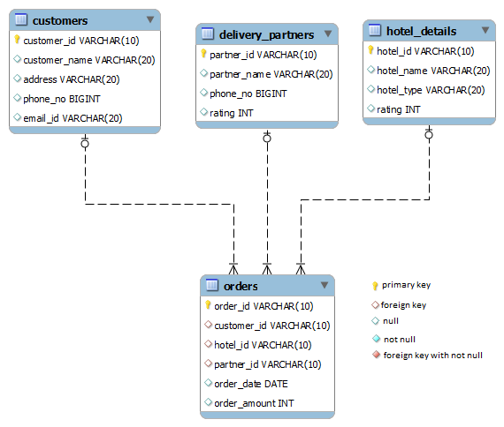

## Hunger eats - change datatype

Refer to the given schema. Assume that the 'Customers' table has been already created.  
Write a query to change the data type of the field customer_id in Customers table to int.  
  
Note: Letters in bold represents the attribute name

**ALTER TABLE customers MODIFY customer_id int;**

## Hunger eats - update table

Refer to the given schema diagram and sample records inserted into the Customers table

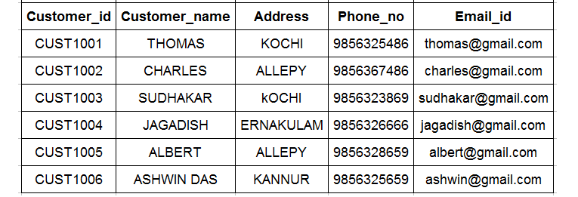

**UPDATE CUSTOMERS**

**SET Phone_no = 9876543210**

**WHERE customer_id = 'CUST1004';**

1. **Delivery Partner details based on rating**

Write a query to display partner id, partner name, phone number of delivery partners whose rating is between 3 to 5, sort the result based on partner id.

(Hint: Use Delivery_partners table to retrieve records.)

NOTE: Maintain the same sequence of column order, as specified in the question description

**select partner_id,partner_name,phone_no**

**from delivery_partners**

**where rating between 3 and 5 order by 1**

## Hunger eats - Change the field name

Write appropriate query/queries for the given requirement. Assume, Hotel_Details table has been already created.  
  
Requirement 1: Change the name of the existing field Rating to Hotel_Rating in the  Hotel_Details table.  
  
Note: Letters in the bold represents the attributes

**ALTER TABLE HOTEL_DETAILS CHANGE rating hotel_rating int;**

### Querying Database - Operators,  Aggregate, String, Date Functions

SCHEMA

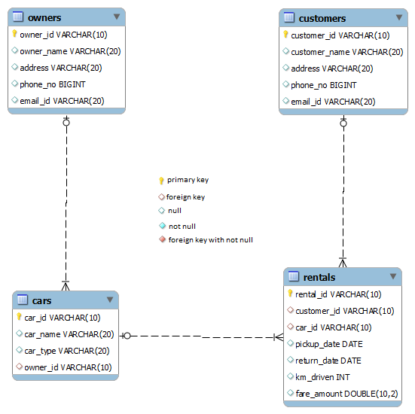

## Rental details based on date

Write a query to display rental id, car id, customer id and km driven of rentals taken during 'AUGUST 2019'.  Sort the result based on rental id.

(HINT : Use Rentals table to retrieve records. Eg: return date: 2019-08-12 )

NOTE: Maintain the same sequence of column order, as specified in the question description

**select rental_id,car_id,customer_id,km_driven from rentals where extract(month from return_date)=08 and extract(year from return_date)=2019 order by 1;**

## Customer contact details

Write a query to display the customer id, customer name and contact details of customers. If address is missing, display the email id. If both address and email is missing then display ‘NA’. Give an alias name as CONTACT_DETAILS.Sort the results based on customer id in ascending order.

(HINT : Use Customers table to retrieve records.)

**select customer_id,customer_name,coalesce(address,email_id,'NA') as Contact_Details from customers**

**order by 1;**

## No of time rented by each car

Write a query to display car id and number of times car taken for rental. Give an alias name to the number of times car taken for rental as 'NO_OF_TRIPS'. Sort the records based on car id in ascending order.

(HINT: Use Rentals table to retrieve records.)

**select car_id,count(rental_id) as No_Of_Trips from rentals group by car_id order by 1;**

## Credential details

Refer to the schema. Write a query to display the username and password of all owners. Give an alias name as USERNAME and PASSWORD. Sort the result based on the username in ascending order.

Username and password is generated as mentioned below

USERNAME: concatenate the owner's name with owner id.

PASSWORD: concatenate first 3 character of owner name with owner id.

For Example:

Owner_id - 01

Owner_name - jeeva

**Sample Output:**

|  |  |
| --- | --- |
| USERNAME | PASSWORD |
| jeeva01 | jee01 |

(HINT: Use Owners table to retrieve records.)

NOTE: Maintain the same sequence of column order, as specified in the question description

**select concat(owner_name,owner_id) as Username,concat(substr(owner_name,1,3),owner_id) as Password**

**from Owners order by username;**

## Maruthi car owner details

Write a query to display distinct owner id, owner name, address, and phone no of owners who owns 'Maruthi' company car.  Sort the result based on owner id.

Note: If car_name contains a string 'Maruthi' it is a Maruthi company car.

Example: 'Maruthi swift','Maruthi 800'

(HINT: Use Owners and Cars tables to retrieve records.)

NOTE: Maintain the same sequence of column order, as specified in the question description

**select distinct o.owner_id,owner_name,address,phone_no**

**from owners o join cars c on o.owner_id=c.owner_id**

**where car_name like 'Maruthi%' order by 1;**

## Cars not taken for rent

Write a query to display car id, car name, car type of cars which was not taken for rent.  Sort the result based on car id.

(HINT: Use Cars and Rentals tables to retrieve records.)

NOTE: Maintain the same sequence of column order, as specified in the question description

**select car_id,car_name,car_type from cars where car_id not in(select car_id from rentals) order by 1;**

SCHEMA



## Hotels that took order based on month

Write a query to display distinct hotel id, hotel name, and rating of hotels that have taken order in the month of July. Sort the result based on hotel id in ascending order.

(HINT: Use Hotel_details and  Orders tables to retrieve records.Order date='2019-07-14')

NOTE: Maintain the same sequence of column order, as specified in the question description

**select hotel_id,hotel_name,rating from hotel_details**

**where hotel_id in(select hotel_id from orders**

**where extract(month from order_date)=07) order by 1;**

## Review of delivery partner based on rating

Write a query to display partner id,partner name and review of the delivery partner, give alias name for partner review as 'REVIEW', sort the result based on partner id in ascending order.

Note: Review is based on the following condition

IF rating>=4 ----> 'GOOD'

IF rating between >=2 and <4 -----> 'AVERAGE'

IF rating <2 ------------>'WORST'

(HINT : Use Delivery_partners table to retrieve records.)

**select partner_id,partner_name,**

**CASE when rating>=4 then 'GOOD'**

**when rating between 2 and 4 then 'AVERAGE'**

**when rating<2 then 'WORST'**

**end**

**as REVIEW from delivery_partners order by 1;**

## Total sale daywise

Write a query to display order_date, total order amount in each day. Give an alias name for total order amount as ‘TOTAL_SALE’. Sort the result based on order_date.

(HINT : Use Orders table to retrieve records.)

NOTE: Maintain the same sequence of column order, as specified in the question description

**select order_date,sum(order_amount) as Total_Sale from orders**

**group by order_date order by 1;**

## Hotels not taken orders in a specific month

Write a query to display hotel id, hotel name and hotel type of hotels which has not taken any orders in the month of 'MAY 19'. Sort the result based on hotel id in ascending order.

(HINT: Use Hotel_details and Orders tables to retrieve records. Eg: order_date= 2019-05-12)

NOTE: Maintain the same sequence of column order, as specified in the question description

**select hotel_id,hotel_name,hotel_type from hotel_details**

**where hotel_id not in(select**

**hotel_id from orders**

**where extract(month from order_date)=05 and extract(year from order_date)=2019) order by 1;**

## Hotels that took order more than five times

Write a query to display hotel id, hotel name, and number of orders taken by hotels that have taken orders more than 5 times. Give an alias name for number of orders as 'NO_OF_ORDERS'.sort the result based on hotel id in ascending order.

(HINT: Use Hotel_details and Orders tables to retrieve records.)

NOTE: Maintain the same sequence of column order, as specified in the question description

**select hotel_id,hotel_name,count(*) no_of_orders**

**from hotel_details natural join orders**

**group by hotel_id,hotel_name**

**having count(*)>5 order by 1;**

## Hotel_info

Refer to the schema. Write a query to display the hotel name along with the type. Display the details in the below format.

Give an alias name as HOTEL_INFO. Sort the result in descending order.

For Example:

          Hotel_name - 'A2B'

          Hotel_type - 'VEG'

**Sample Output:**

|  |
| --- |
| HOTEL_INFO |
| A2B is a VEG hotel |

(HINT: Use Hotel_details table to retrieve records.)

NOTE: Maintain the same sequence of column order, as specified in the question description

**select concat(hotel_name,' is a ',hotel_type,' hotel') as Hotel_info**

**from hotel_details**

**order by hotel_info desc;**

## Customer mail details

Refer to the schema. Write a query to display the customer mail details. Display the details in the below format.

Give an alias name as CUSTOMER_MAIL_INFO. Sort the result in ascending order.

For Example:

          Customer_id - 'CUST001'

          Email_id - 'mano@hotmail.com'

**Sample Output:**

|  |
| --- |
| CUSTOMER_MAIL_INFO |
| CUST001 mail id is mano@hotmail.com |

(HINT: Use Customers table to retrieve records.)

NOTE: Maintain the same sequence of column order, as specified in the question description

**select concat(customer_id,' mail id is ',email_id) as CUSTOMER_MAIL_INFO**

**from customers**

**order by customer_mail_info;**

## Order details

Write a query to display order id, customer name, hotel name, and order amount of all orders. Sort the result based on order id in ascending order.

(HINT: Use Customers, Hotel_details and Orders tables to retrieve records.)

NOTE: Maintain the same sequence of column order, as specified in the question description

**select order_id,customer_name,hotel_name,order_amount**

**from customers**

**join orders on customers.customer_id=orders.customer_id**

**join hotel_details on hotel_details.hotel_id=orders.hotel_id**

**order by 1;**